## EXPERIMENT NO:-1

* **AIM:** TO STUDY AND VERIFY TRUTH TABLES OF VARIOUS LOGIC GATES.
* **APPARATUS:** Logic trainer, IC 7402, IC 7400, IC 7408, IC 7432, IC 74266, IC 7486, IC 7404, Connecting wires, LEDs, Multimeter.

## THEORY:

A gate is a logic circuit that has one or more outputs. The outputs of the gate will depend upon the set of input conditions. The digital signal has two states LOW (0) and HIGH (1). Using gates we can implement variety of logic circuit that performs a particular task. For an example we can implement various arithmetic, logical and control units depending upon our requirement. Various types of gates are described below.

1. **NOT Gate**: This gate has one input and one output. This gate inverts input at the output. When input is LOW output is HIGH and vice versa.

SYMBOL:

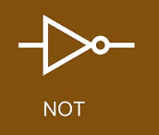

BOOLEAN EXPRESSION: _

Y = A

TRUTH TABLE:

## Table 1: NOT GATE

|  |  |  |
| --- | --- | --- |
| Input | Output | Voltages |
| A | Y = | (V) |
| 0 | 1 |  |
| 1 | 0 |  |

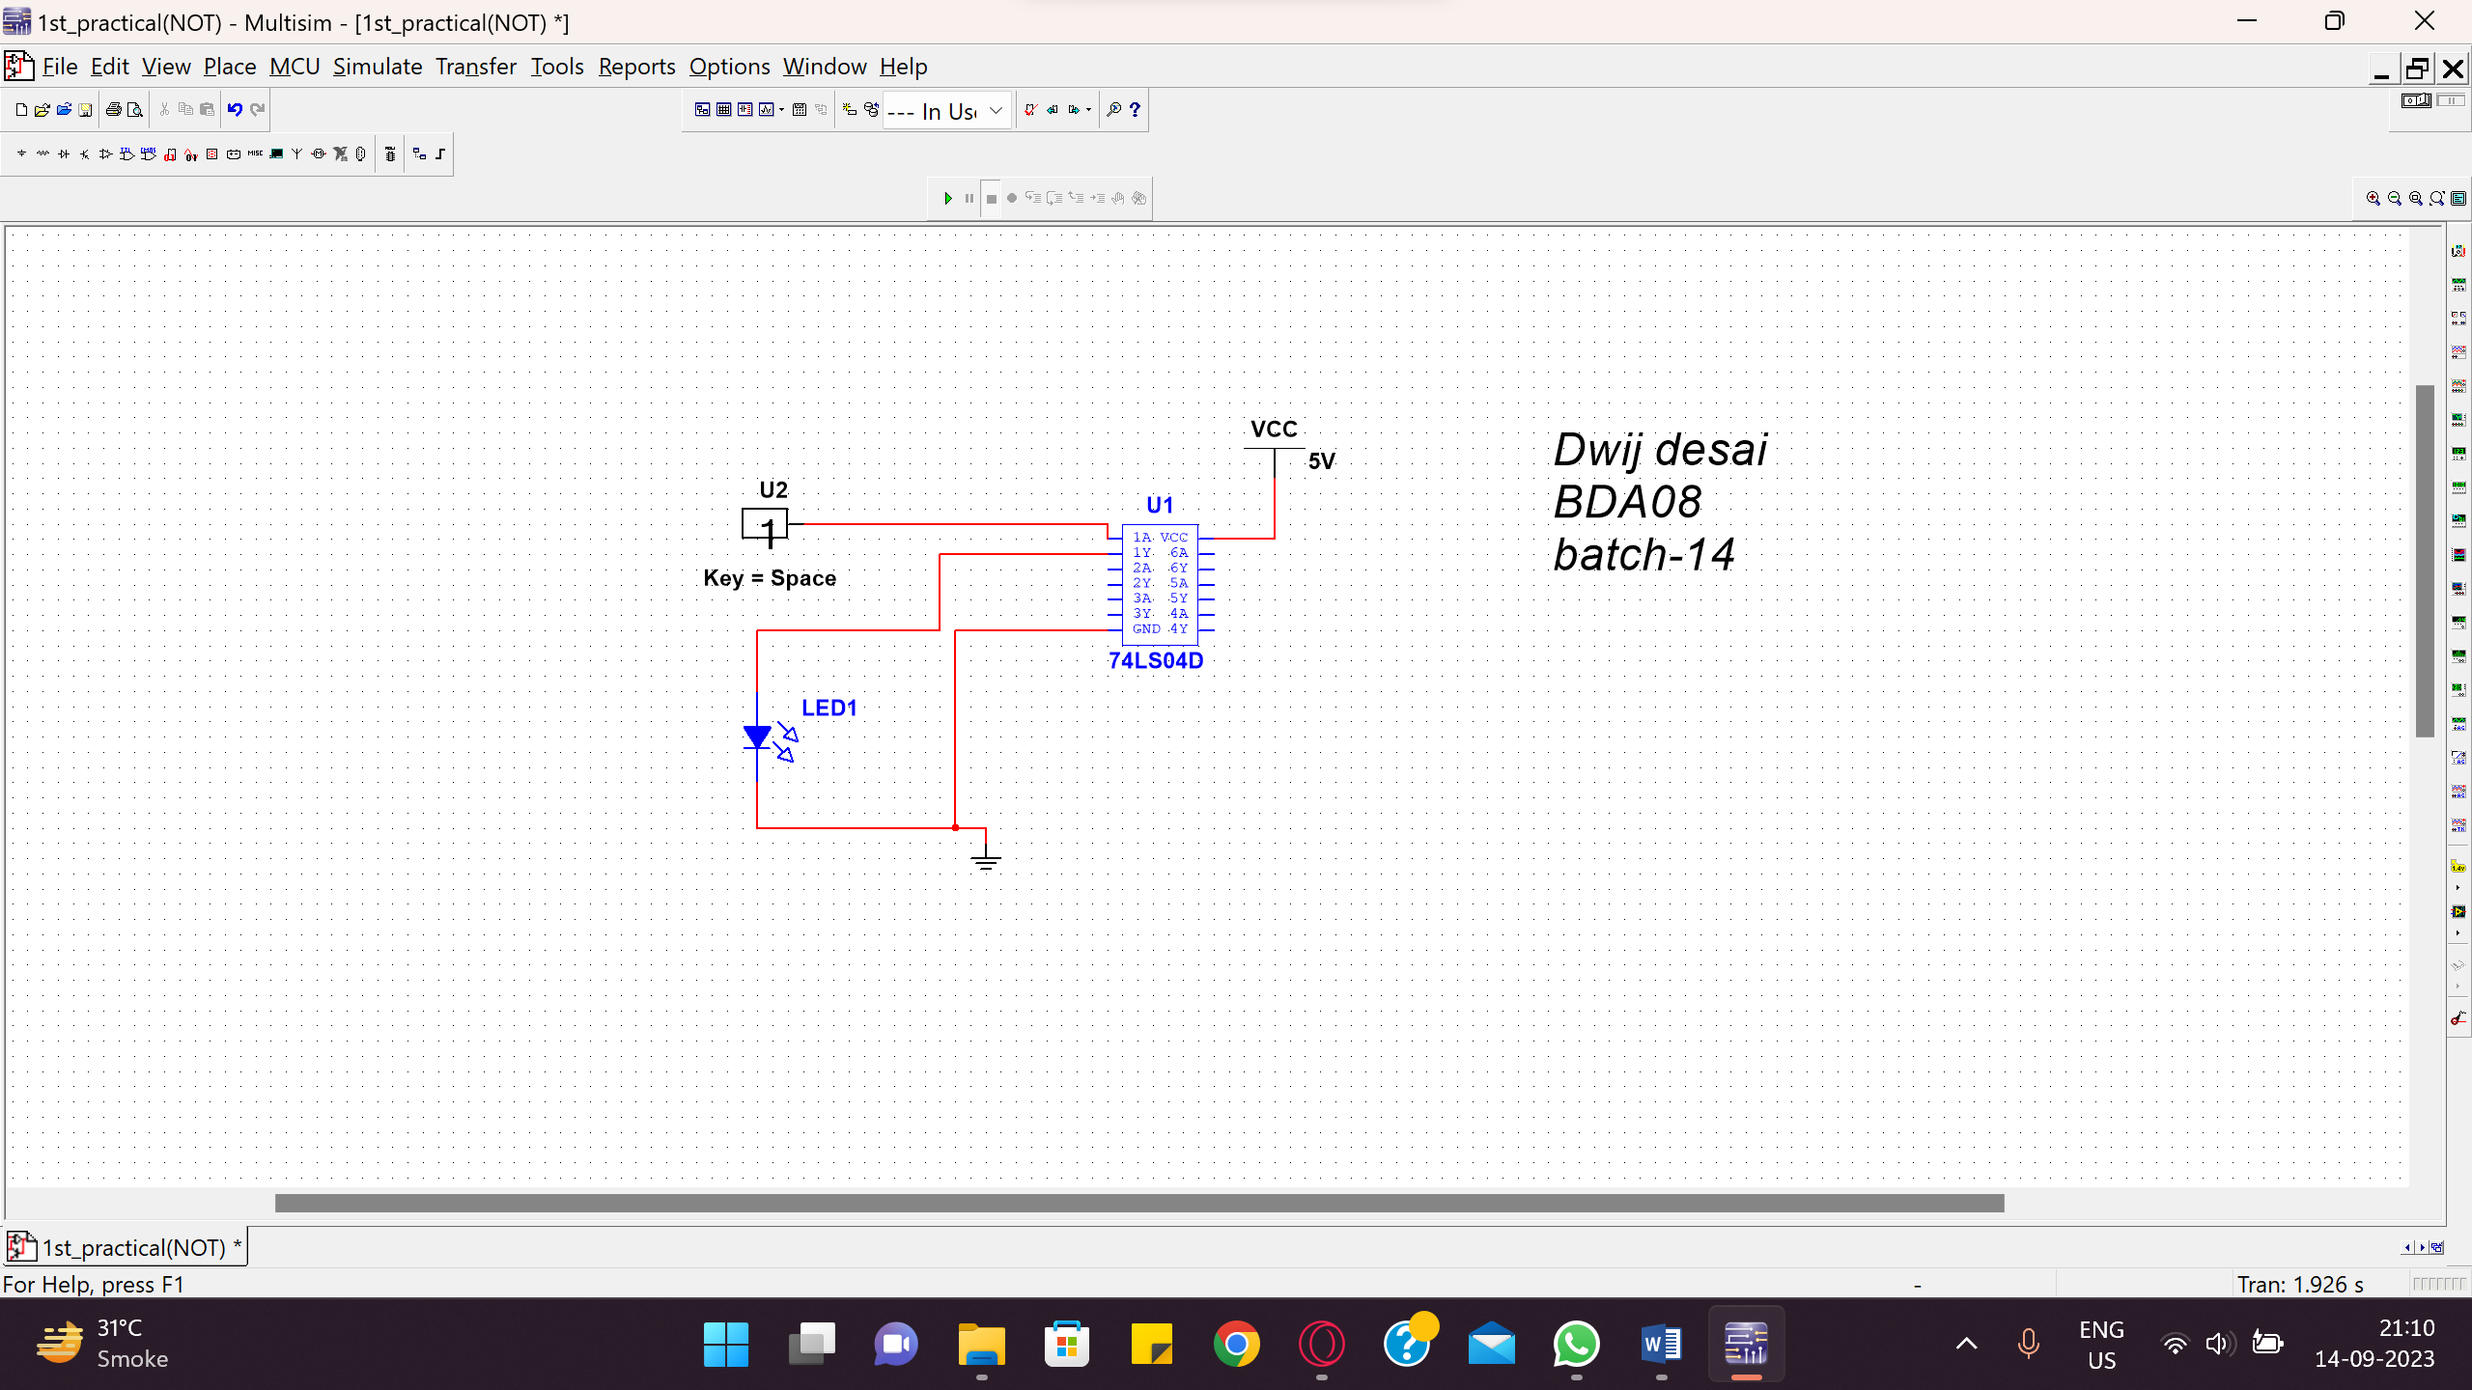

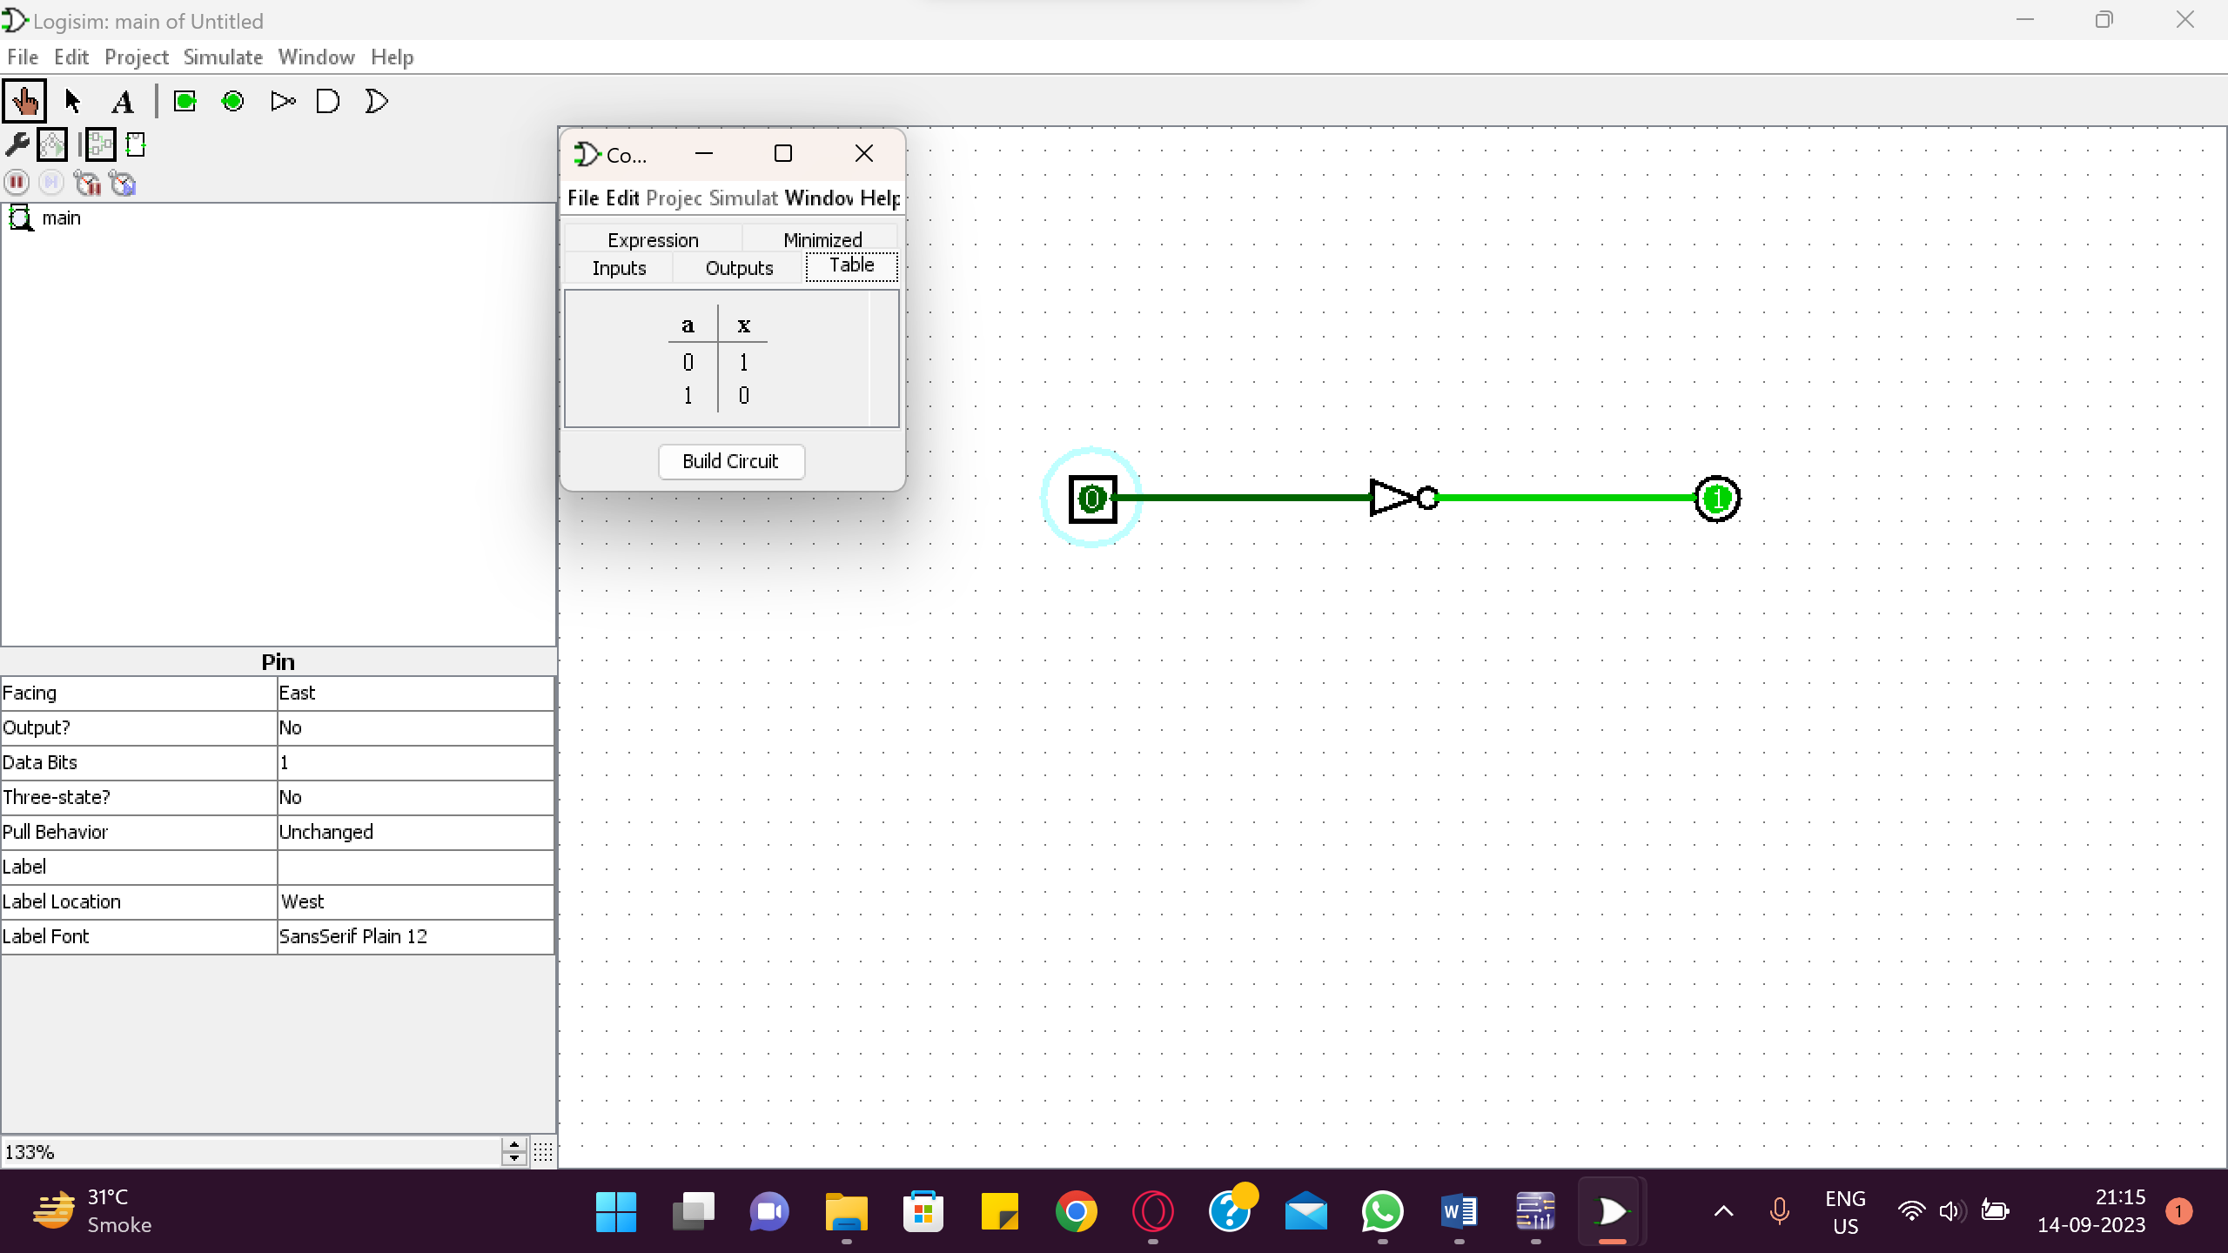

1. **AND Gate**:This gate has two or more inputs and one output. Output of AND gate will go HIGH when all inputs are HIGH, otherwise output will remain LOW.

SYMBOL

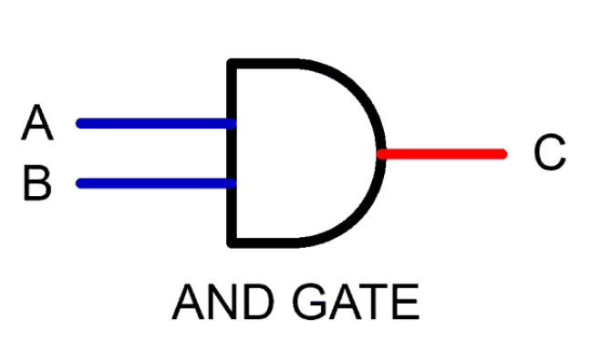

BOOLEAN EXPRESSION:

Y = A⋅B

TRUTH TABLE:

## Table 2 : AND GATE

|  |  |  |  |
| --- | --- | --- | --- |
| Inputs | | Output | Voltages |
| A | B | Y= | (V) |
| 0 | 0 | 0 |  |
| 0 | 1 | 0 |  |
| 1 | 0 | 0 |  |
| 0 | 0 | 1 |  |

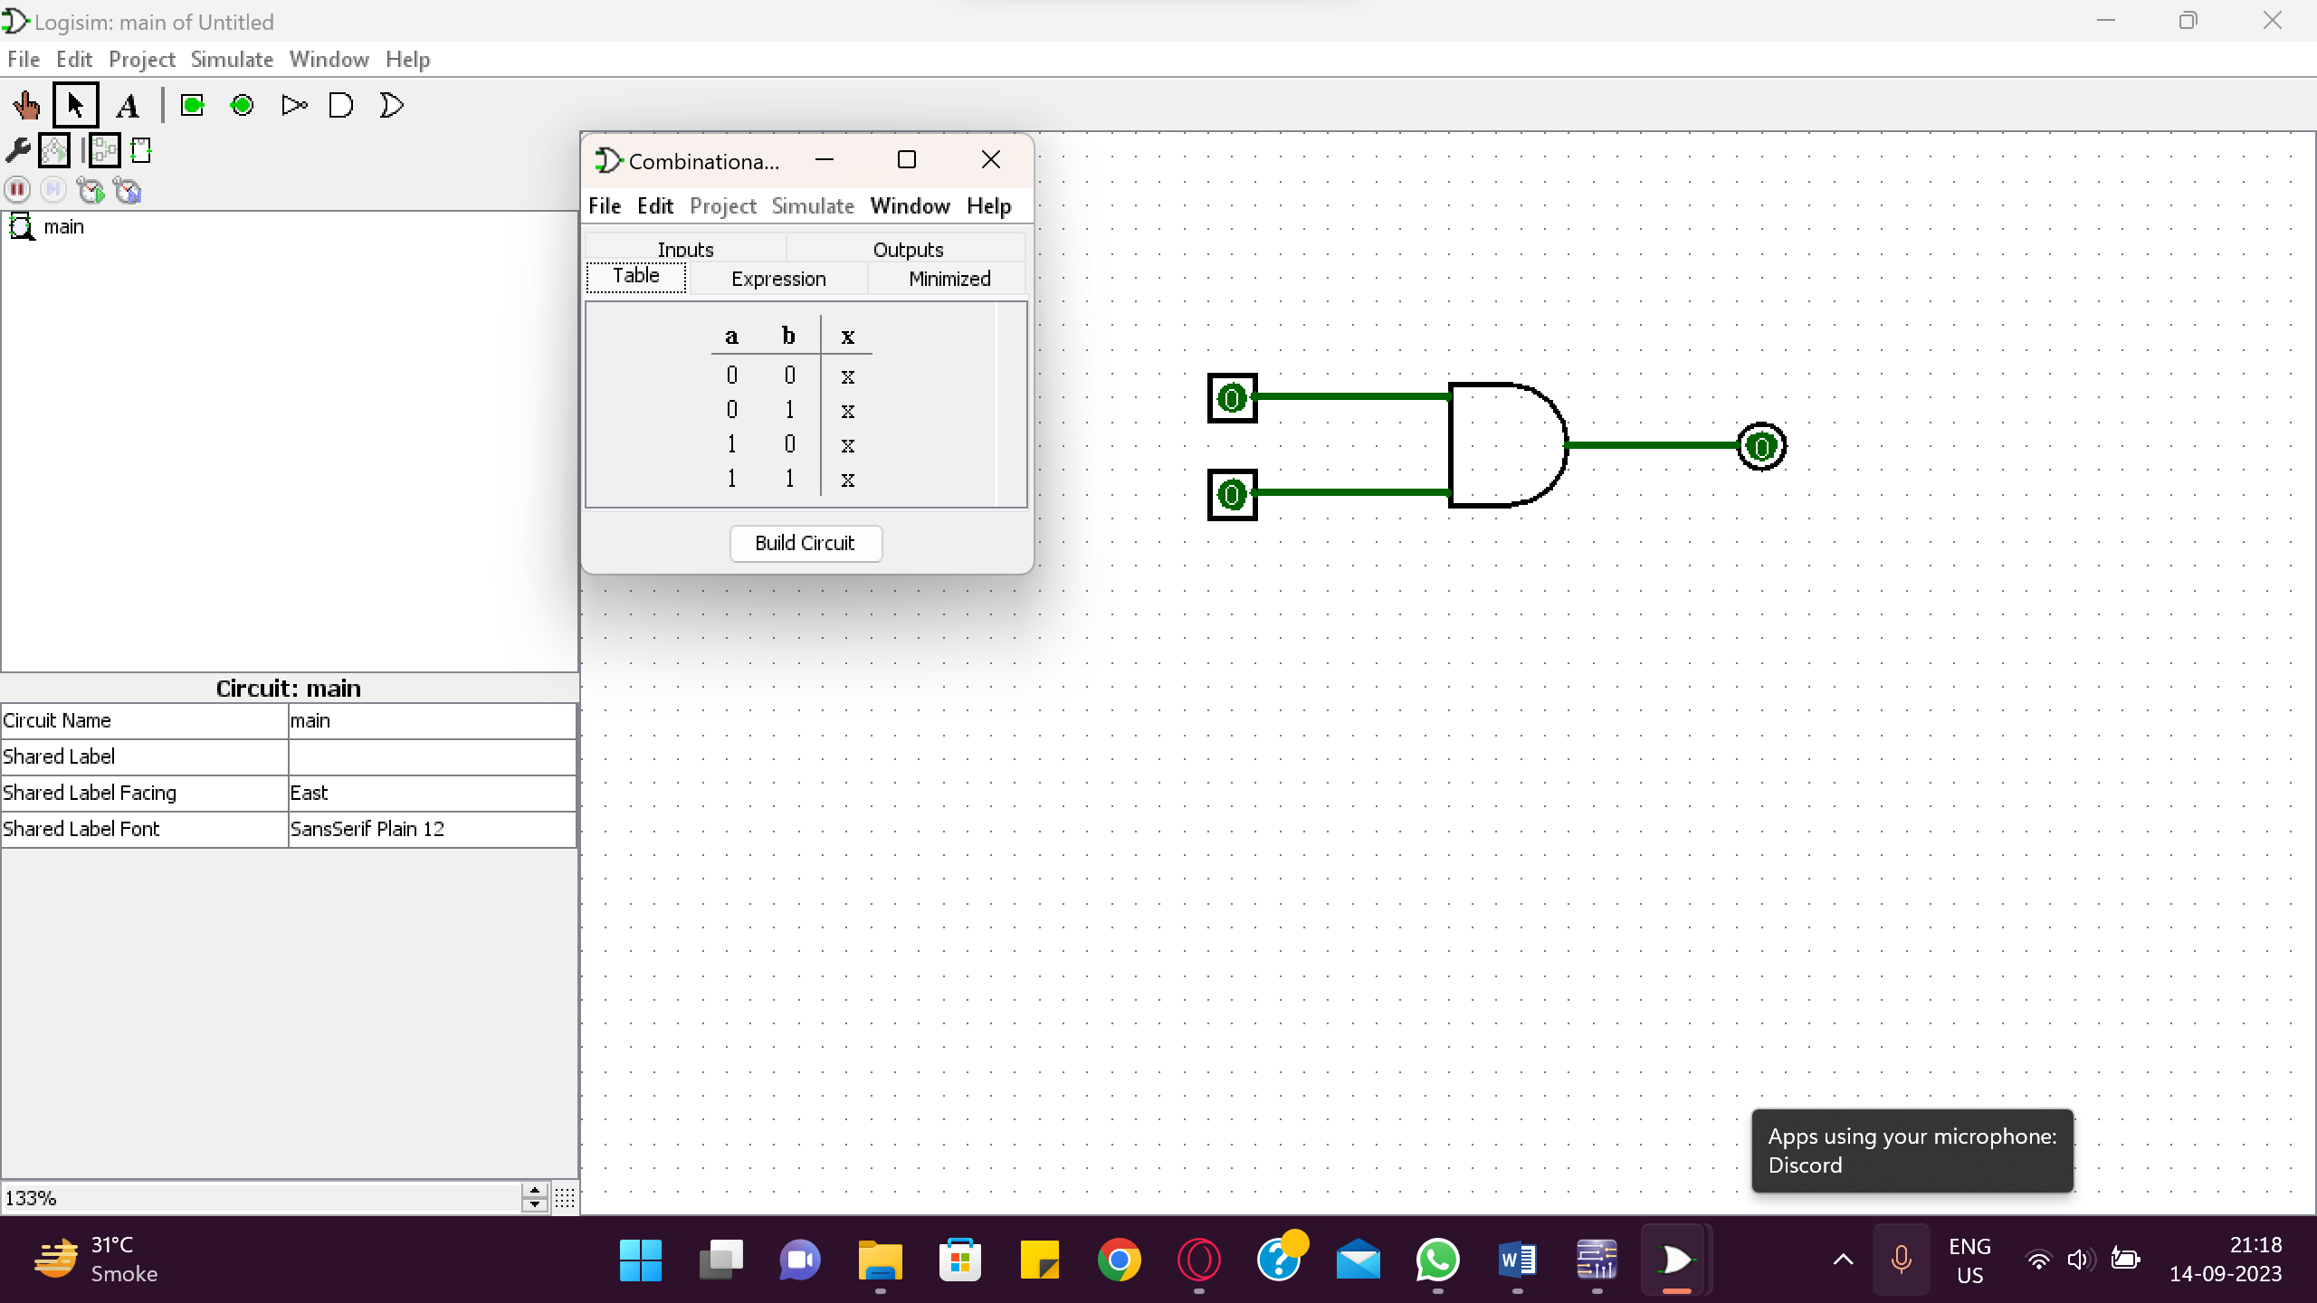

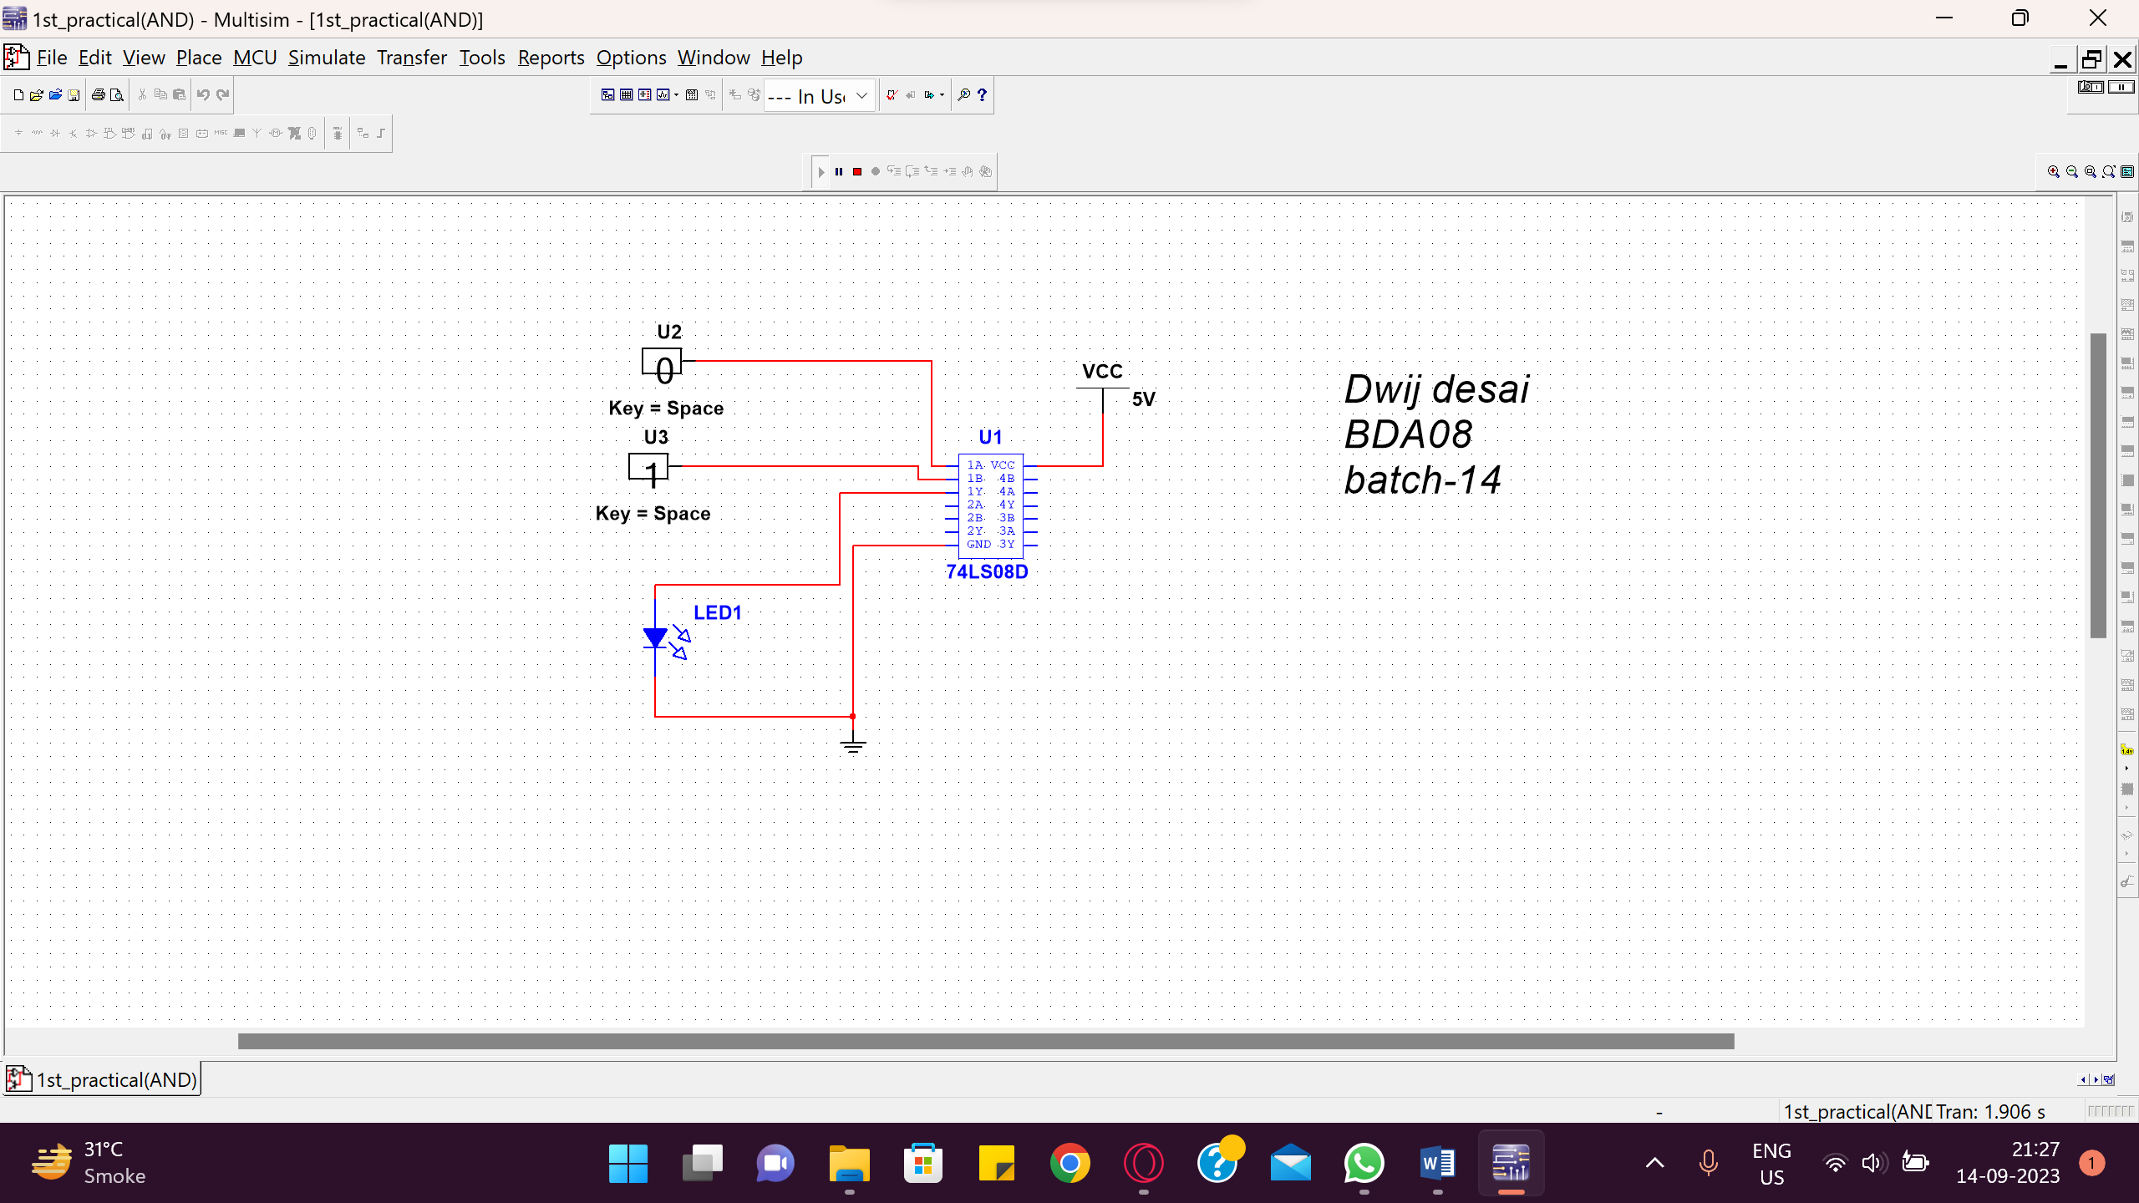

1. **OR Gate**: This gate has two or more inputs and one output. Output of OR gate will go HIGH when any of the input is HIGH. Output is LOW when all inputs are LOW. SYMBOL:



BOOLEAN EXPRESSION:

Y = A + B

TRUTH TABLE:

## Table 3: OR GATE

|  |  |  |  |
| --- | --- | --- | --- |
| Inputs | | Output | Voltages |
| A | B | Y= | (V) |
| 0 | 0 | 0 |  |
| 0 | 1 | 1 |  |
| 1 | 0 | 1 |  |
| 1 | 1 | 1 |  |

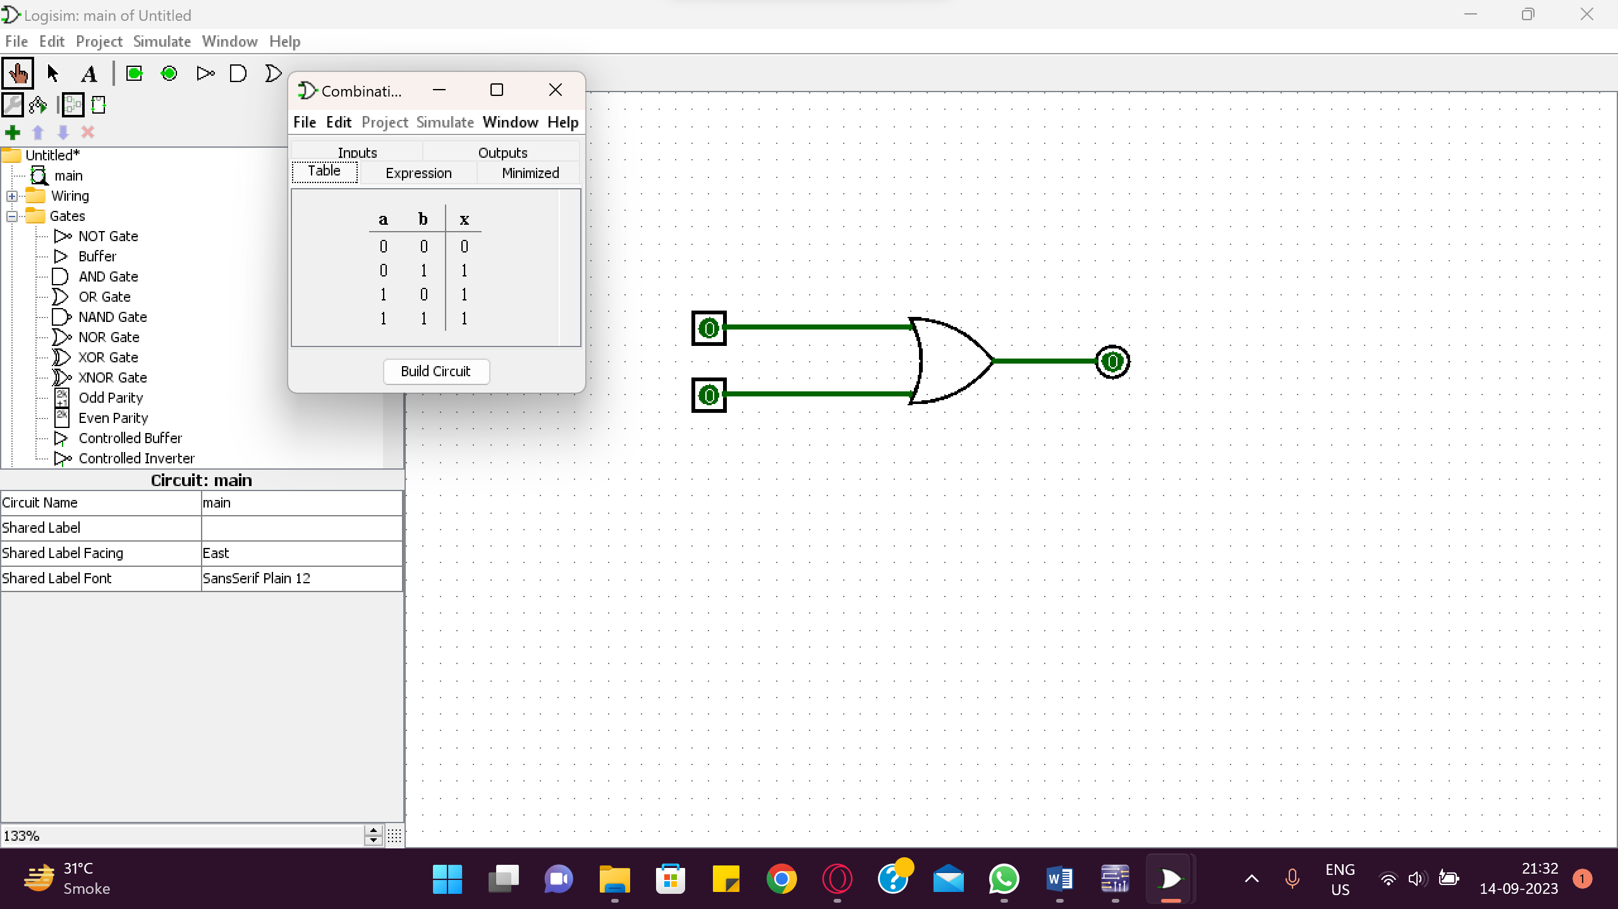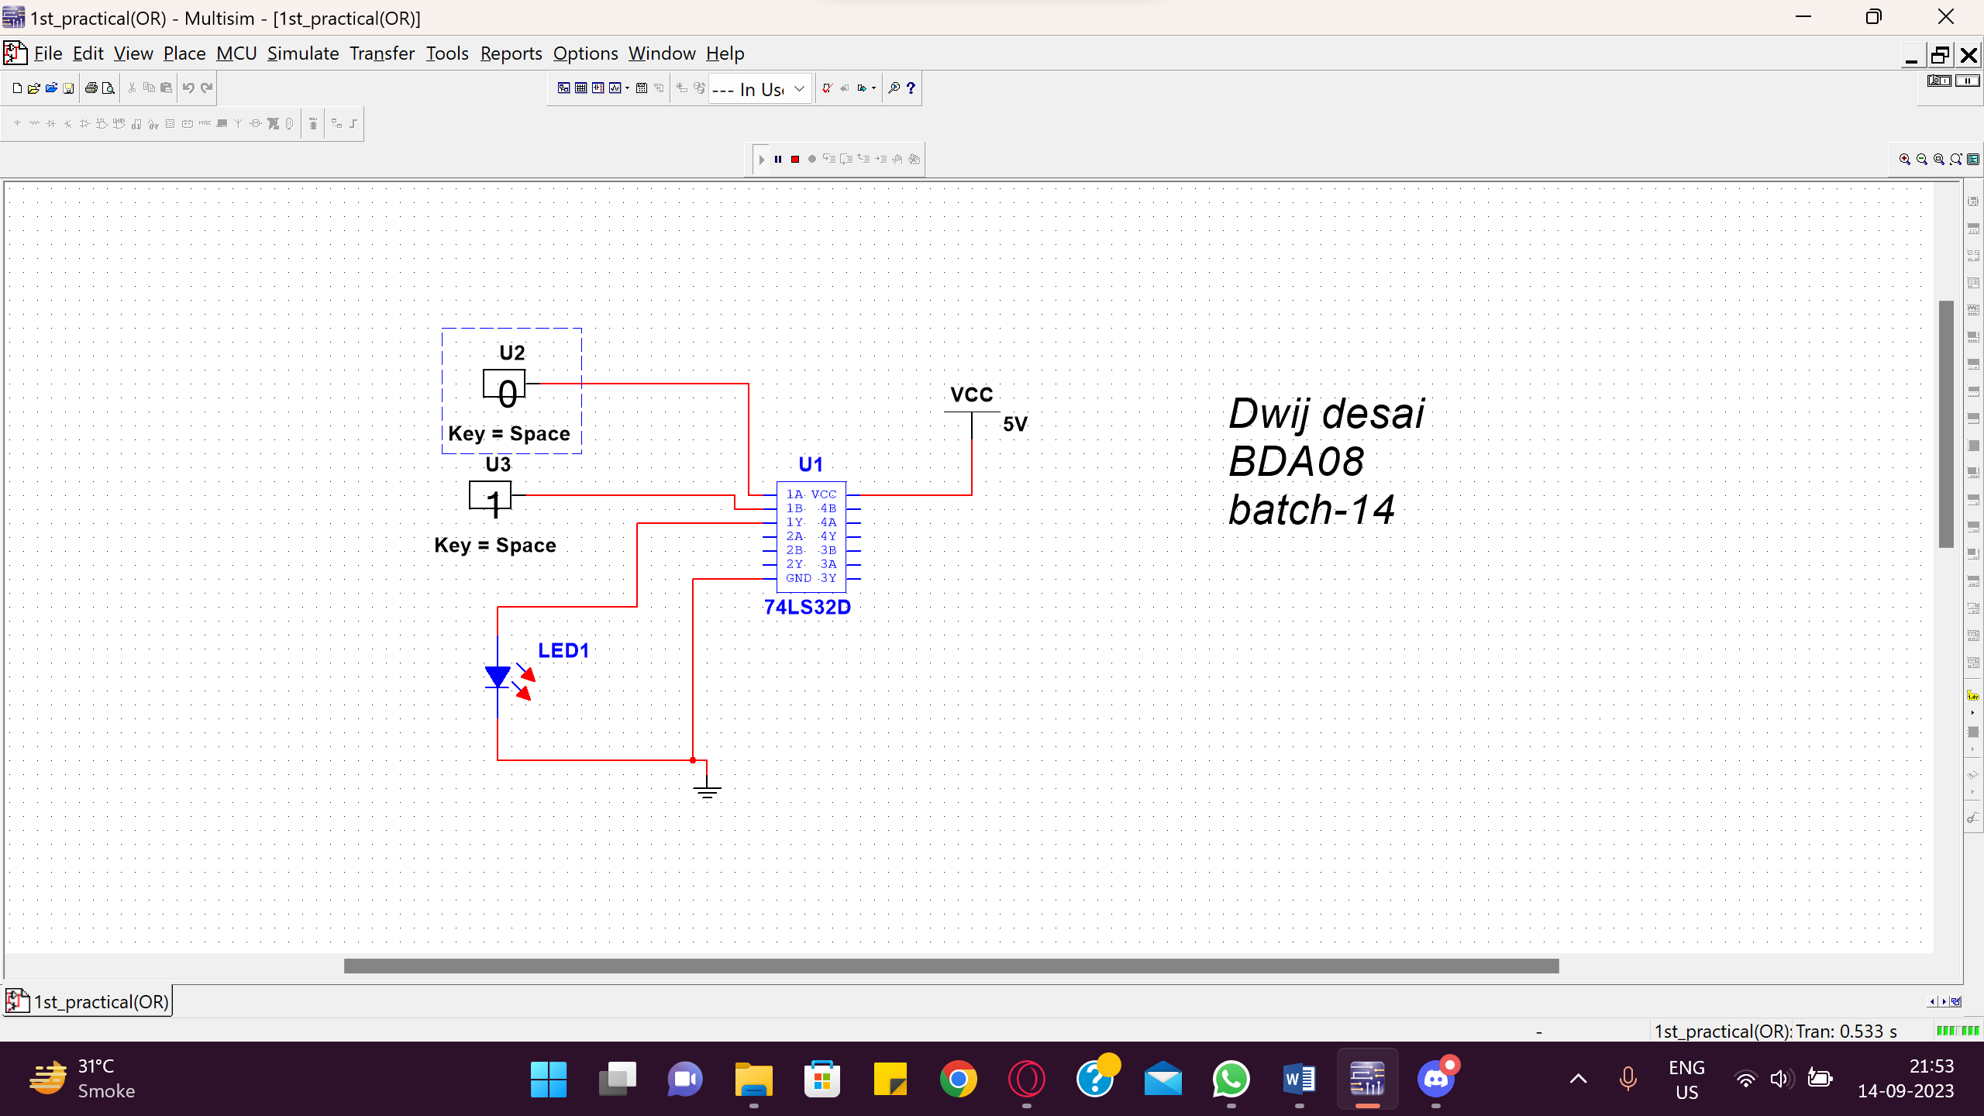

1. **XOR Gate:** This gate has two inputs and one output. Output will go HIGH when all inputs are not of the same logic level (i.e. all inputs are not LOW or not HIGH at a time). SYMBOL:



BOOLEAN EXPRESSION:

Y=

TRUTH TABLE:

## Table 4: XOR GATE

|  |  |  |  |
| --- | --- | --- | --- |
| Inputs | | Output | Voltages |
| A | B | Y= | (V) |
| 0 | 0 | 0 |  |
| 0 | 1 | 1 |  |
| 1 | 0 | 1 |  |
| 1 | 1 | 0 |  |

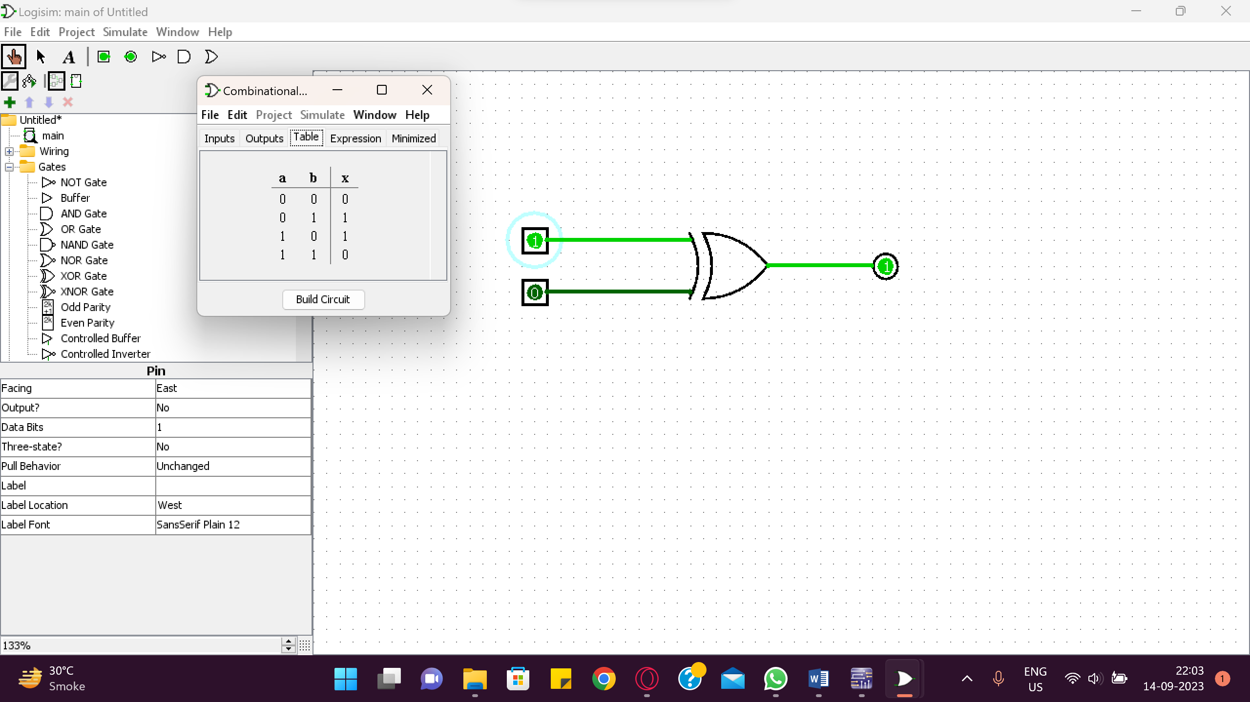

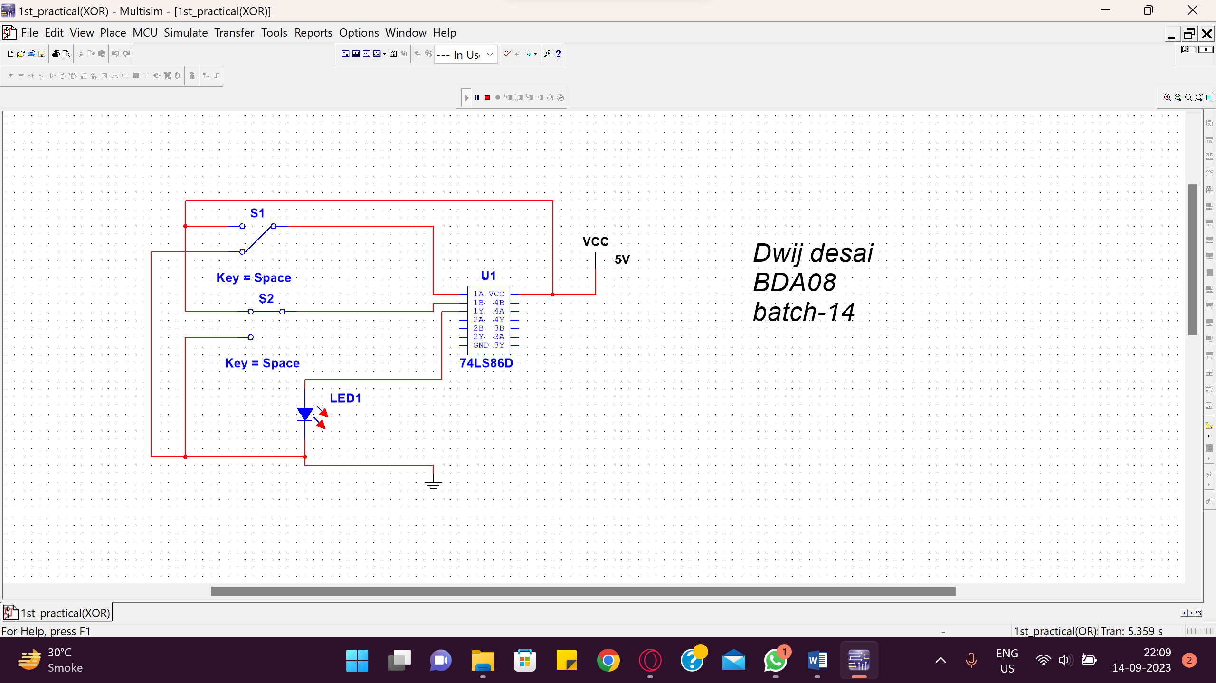

1. **XNOR Gate:** This gate has two inputs and one output. Output will go HIGH when all inputs are of same logic level (i.e. all inputs are LOW or HIGH at a time).

SYMBOL:

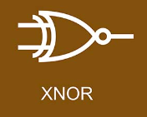

BOOLEAN EXPRESSION: Y =

TRUTH TABLE:

|  |  |  |  |
| --- | --- | --- | --- |
| Inputs | | Output | Voltages |
| A | B | Y= | (V) |
| 0 | 0 | 1 |  |
| 0 | 1 | 0 |  |
| 1 | 0 | 0 |  |
| 1 | 1 | 1 |  |

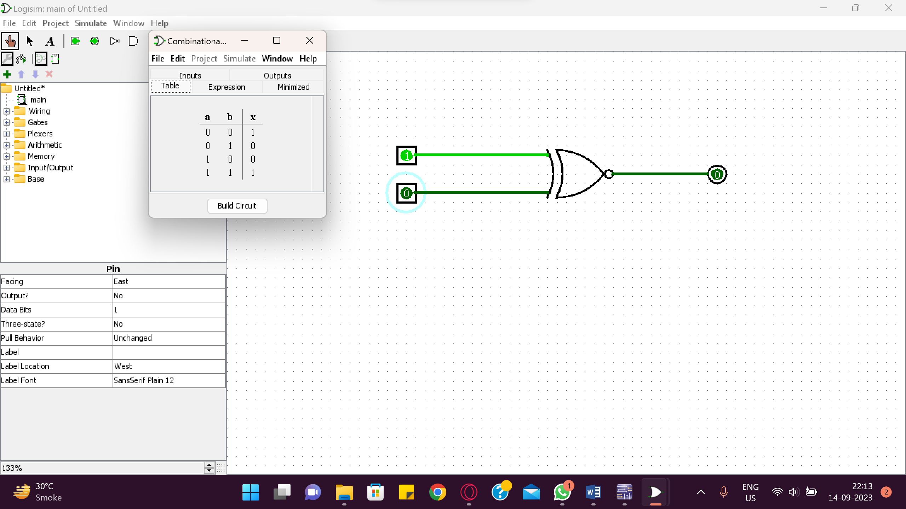

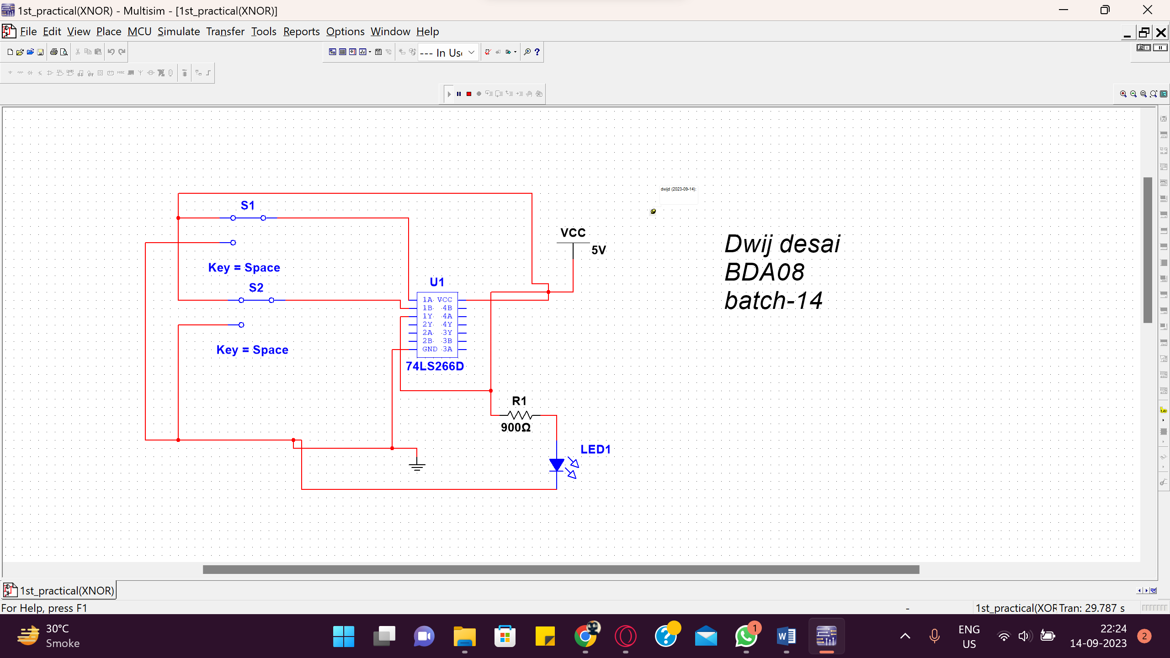

1. **NAND Gate:** If we put one inverter at the output of AND logic gate will be NAND gate.

SYMBOL:

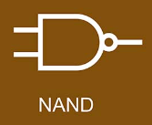

BOOLEAN EXPRESSION: Y = A⋅B

TRUTH TABLE:

## Table 6: NAND GATE

|  |  |  |  |
| --- | --- | --- | --- |
| Inputs | | Output | Voltages |
| A | B | Y= | (V) |
| 0 | 0 | 1 |  |
| 0 | 1 | 1 |  |
| 1 | 0 | 1 |  |
| 1 | 1 | 0 |  |

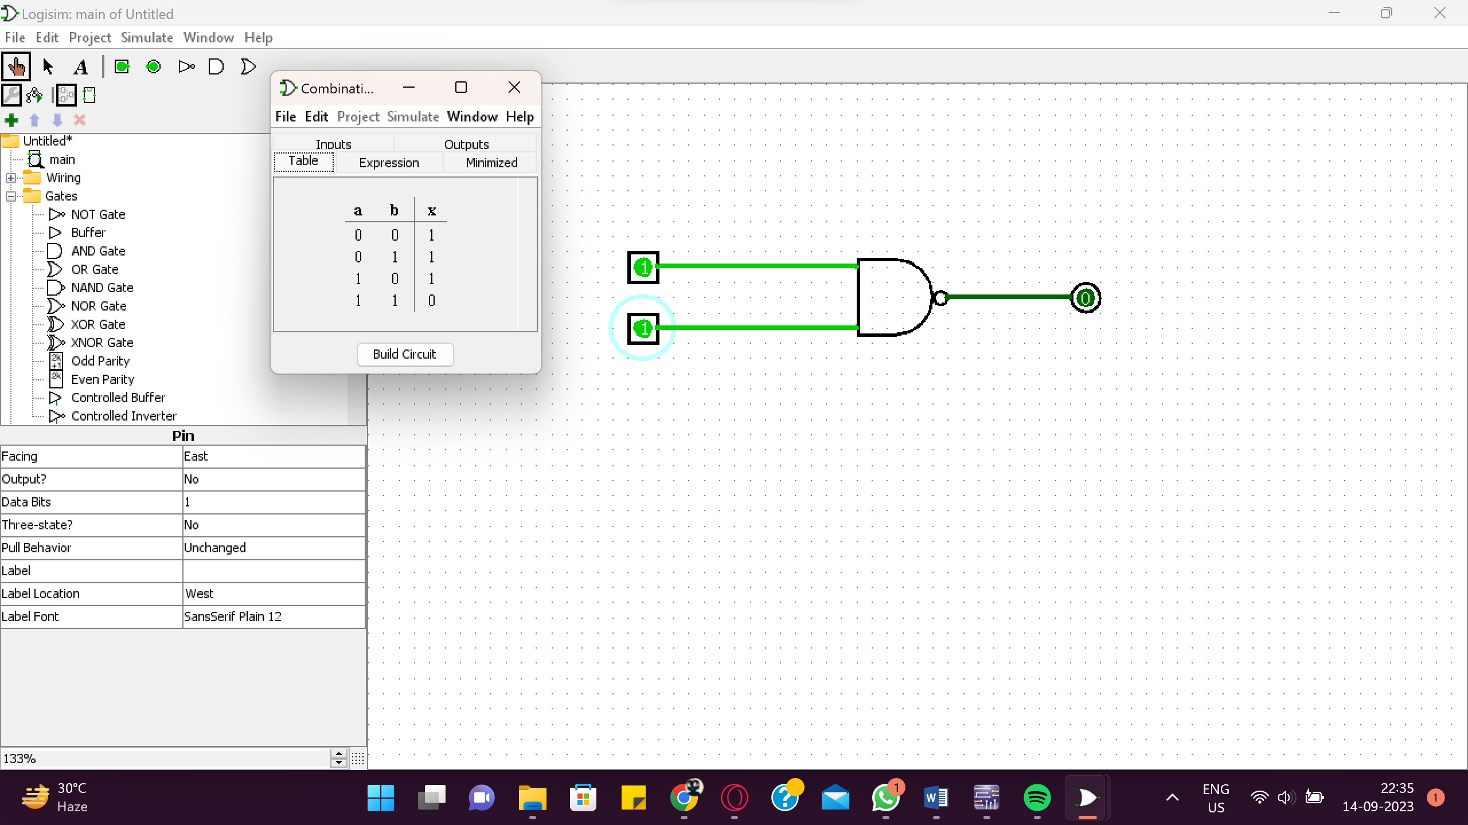

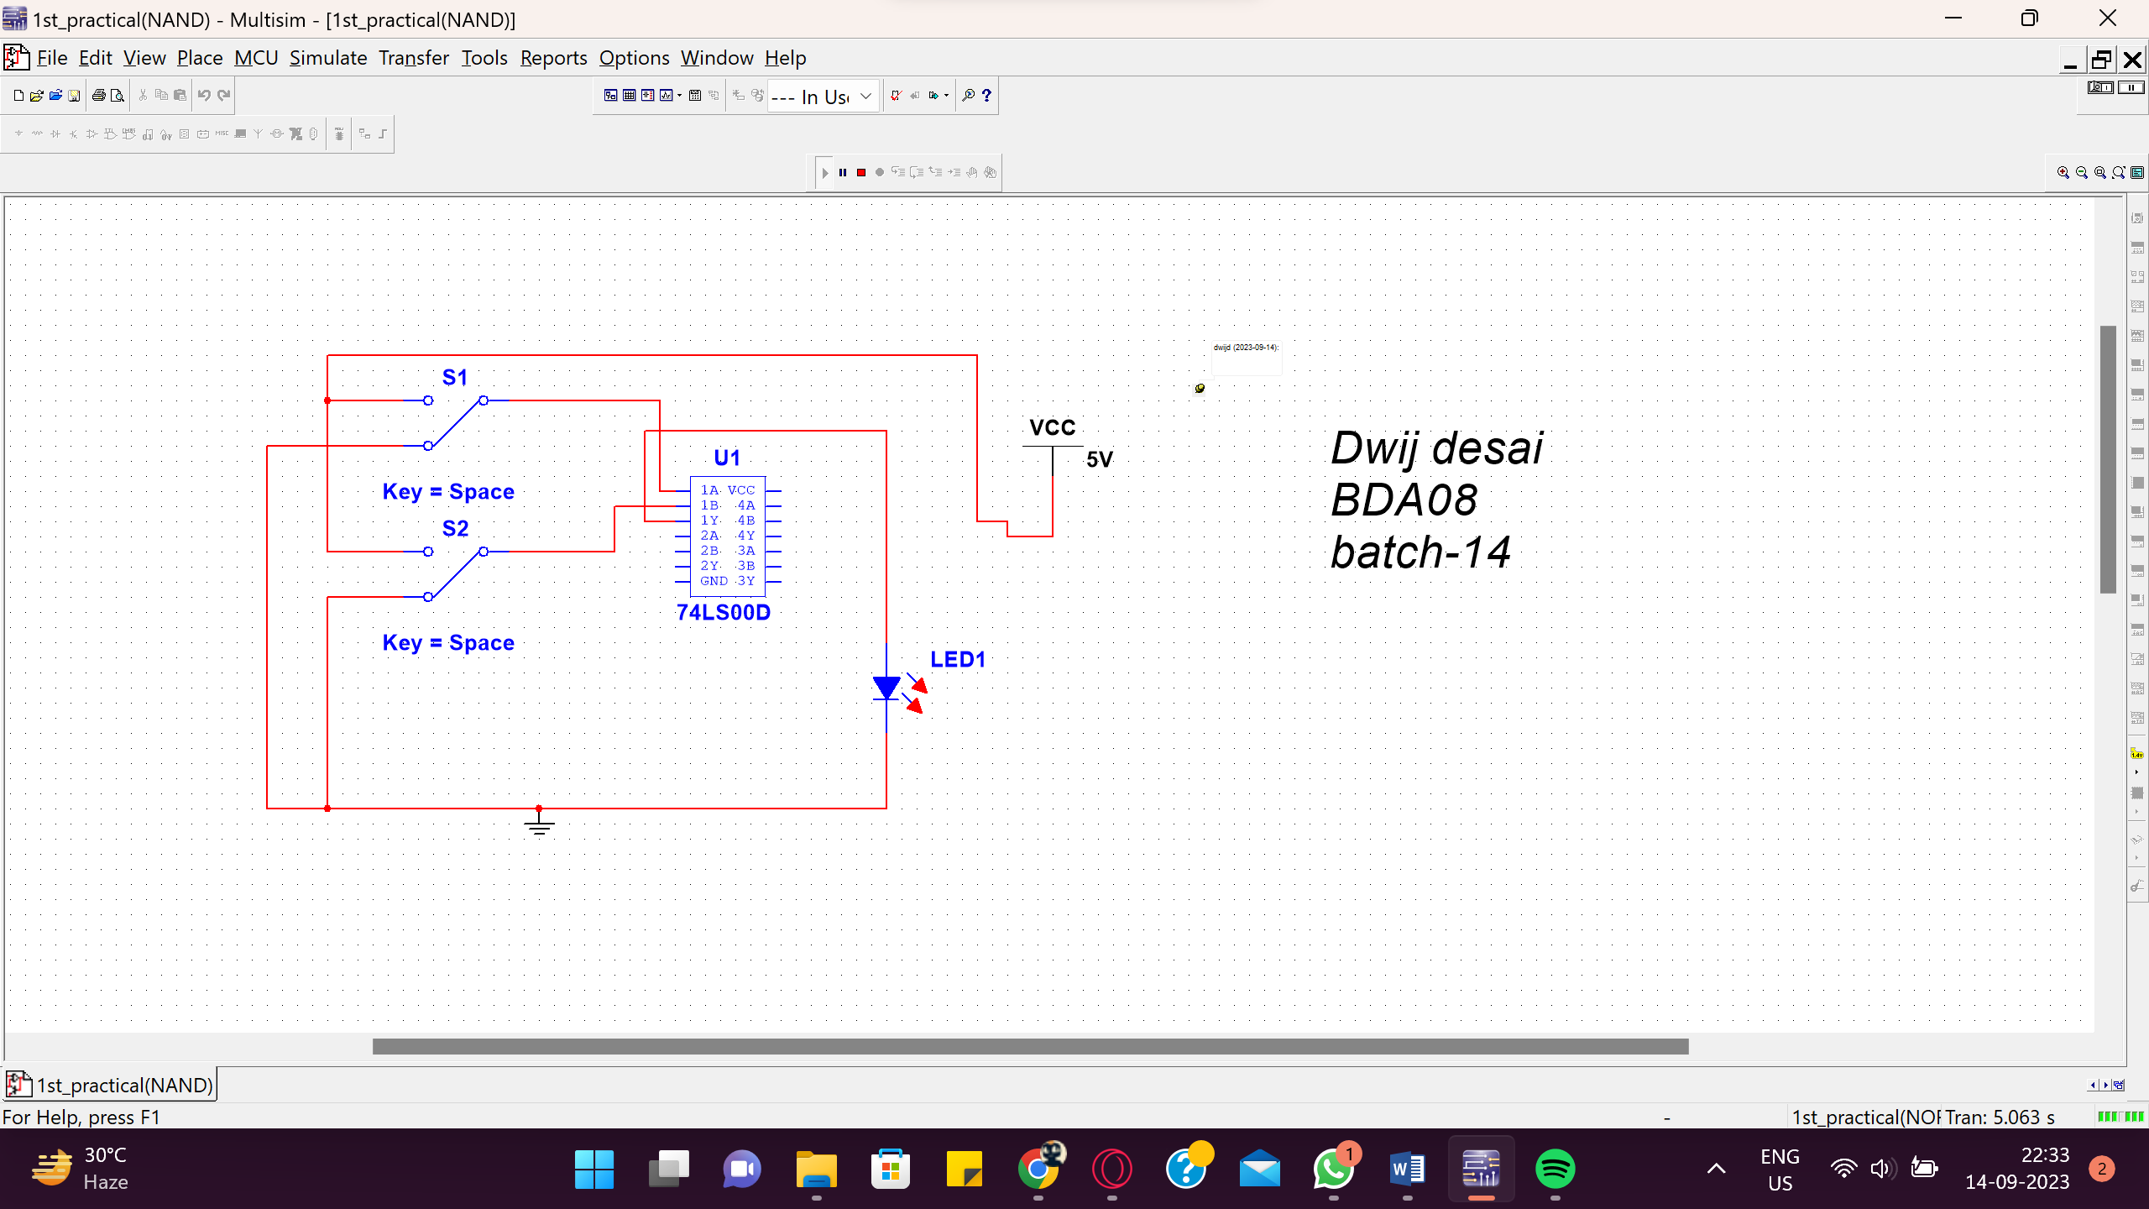

* **PROCEDURE:**
  1. Select appropriate IC for each logic gate
  2. Make the connections according to the requirements.
  3. Make sure the connections of Vcc and grounds are at their respective pins
  4. Switch on the power and apply sequence of inputs and observe outputs.

**Table 7: NOR GATE**

## 

## _____

## Y = A + B

|  |  |  |  |
| --- | --- | --- | --- |
| Inputs | | Output | Voltages |
| A | B | Y= | (V) |
| 0 | 0 | 1 |  |
| 0 | 1 | 0 |  |
| 1 | 0 | 0 |  |
| 1 | 1 | 0 |  |

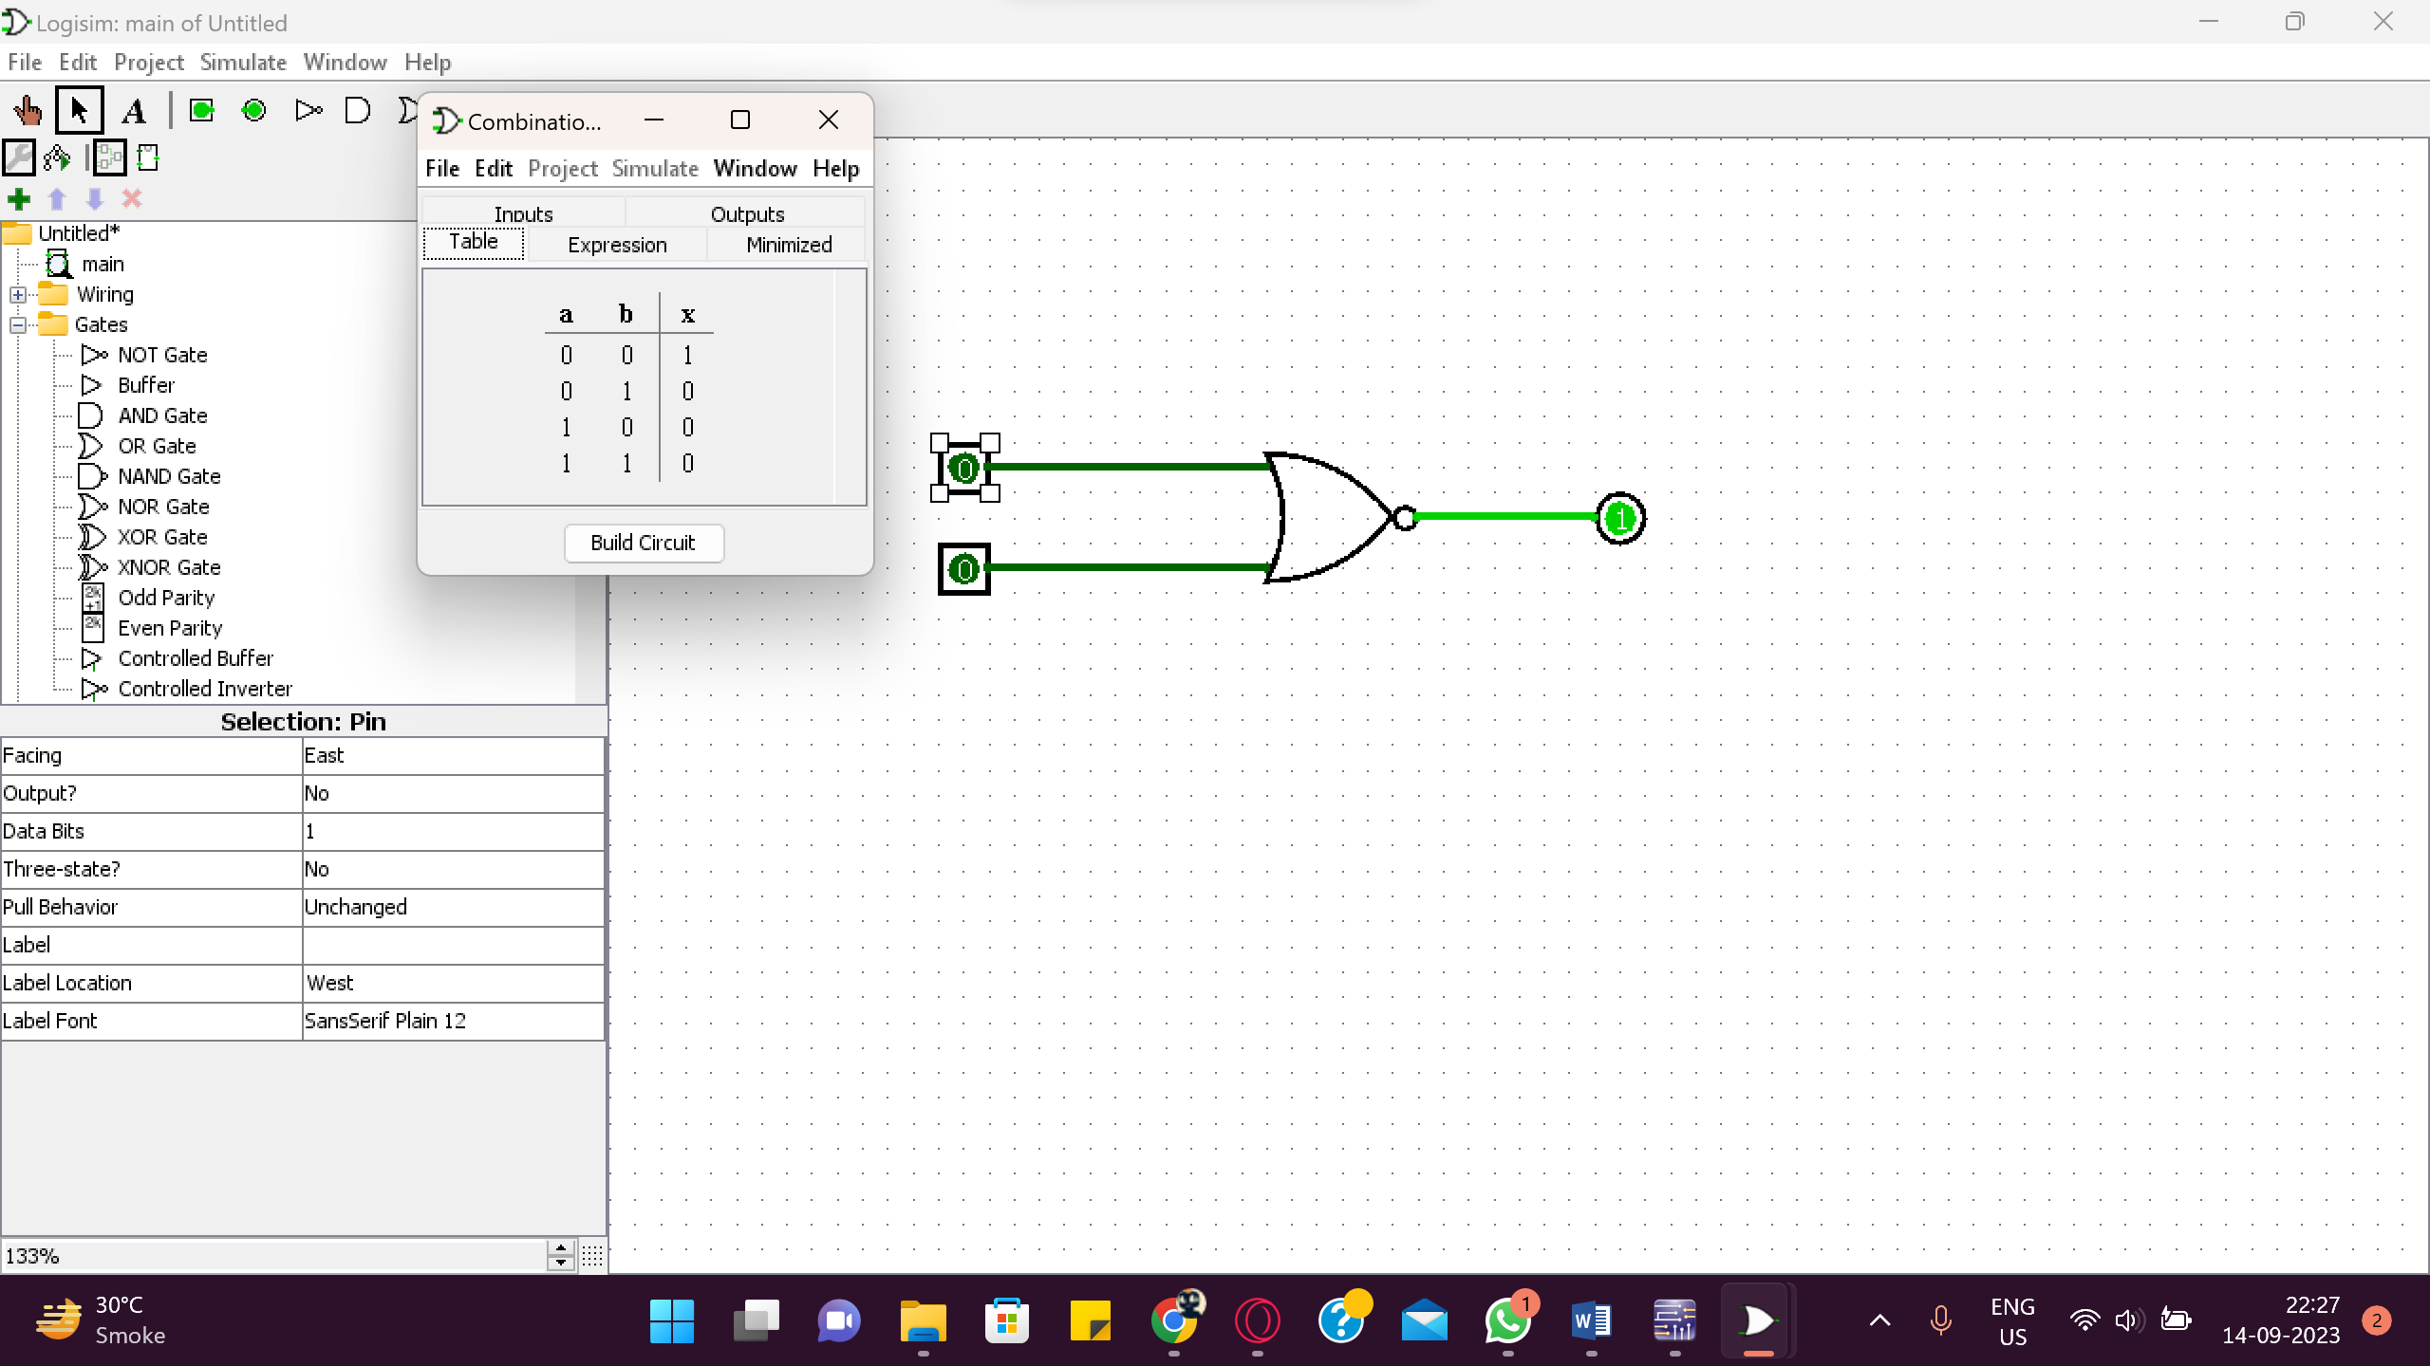

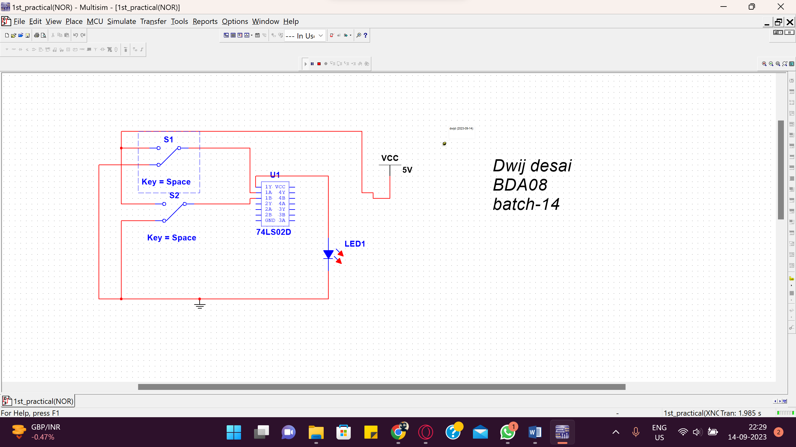

➢ PROCEDURE:

(1) Select appropriate IC for each logic gate

(2) Make the connections according to the requirements.

(3) Make sure the connections of Vcc and grounds are at their respective pins

(4) Switch on the power and apply sequence of inputs and observe outputs.

## CONCLUSION:

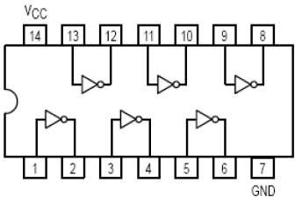

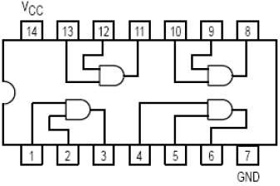

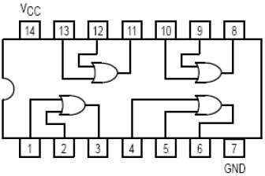

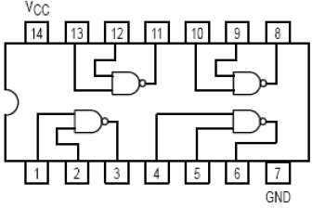

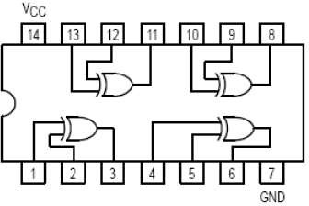



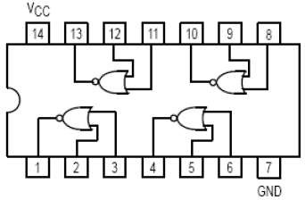

* 1. Input EX-NOR Ic: 74266

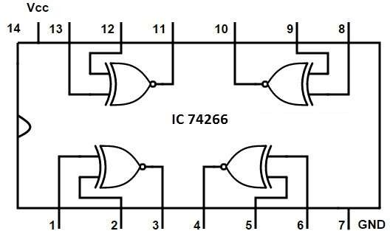

* + - **EXERCISE :**

Draw output waveform of each gate for the given input signals.

1 0

0 1

1 0

**0 1 1 1 0**

**0**

## EXPERIMENT NO:-2

* + - **AIM*:*** To verify the De’Morgan’s Theorems.
    - **APPARATUS :**
      * IC 7400 : Quad - Dual input NAND Gate
      * IC 7402 : Quad – Dual input NOR Gate
      * IC 7408 : Quad – Dual input AND Gate
      * IC 7432 : Quad – Dual input OR gate
      * IC 7404 : Hex – Not gate
    - **THEORY:**

Inverting all inputs to a gate reverses that gate’s essential function from AND to OR, or vice versa, and also inverts the output. So, an OR gate with all inputs inverted (a Negative-OR gate) behaves the same as a NAND gate, and an AND gate with all inputs inverted (a Negative-AND gate) behaves the same as a NOR gate. DeMorgan’s theorems state the same equivalence in “backward” form: that inverting the output of any gate results in the same function as the opposite type of gate (AND vs. OR) with inverted inputs:

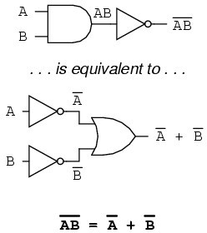

**[A]** Statement and Proof of De’Morgan’s First Law**:**

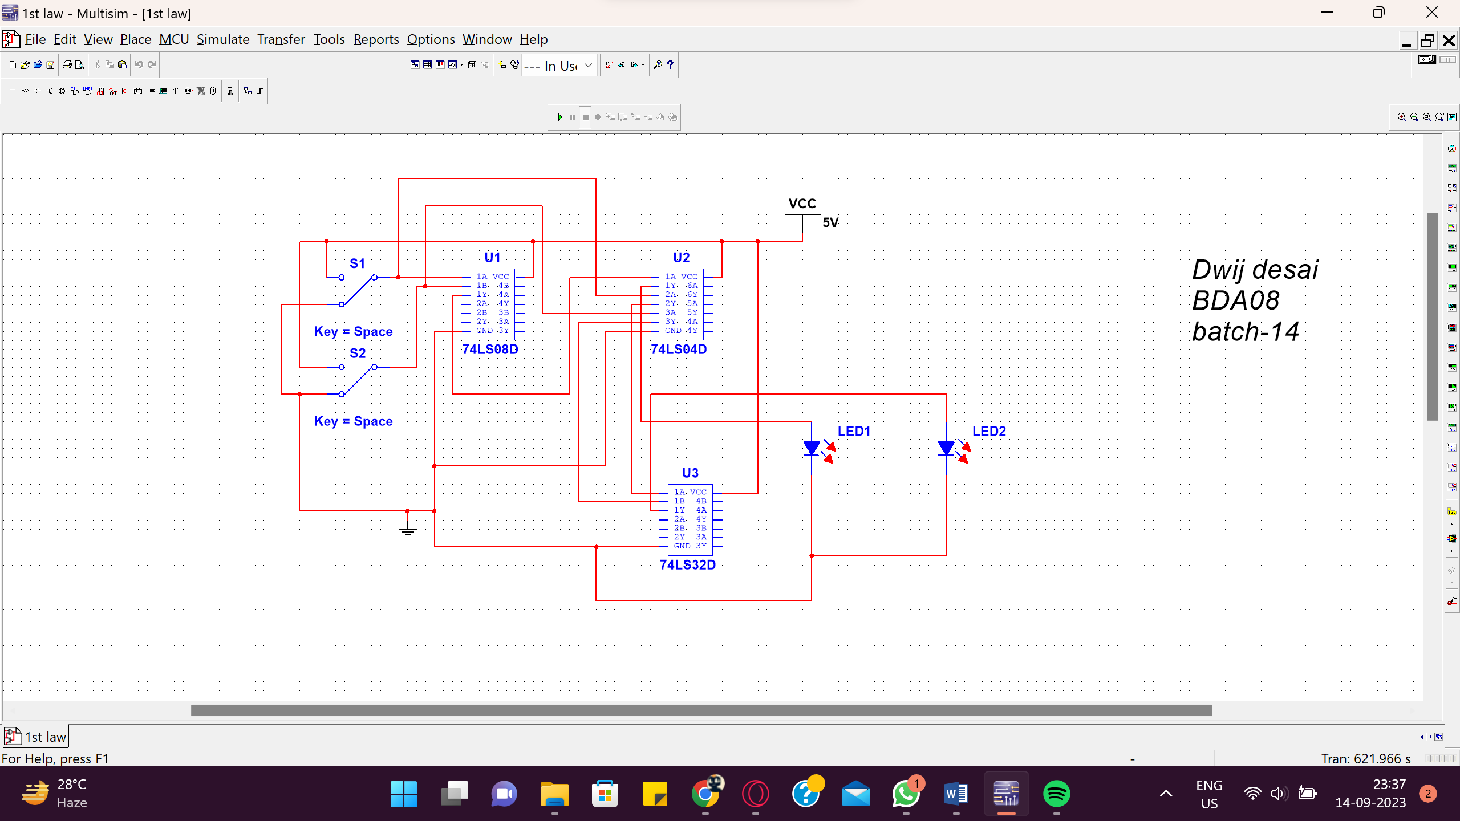

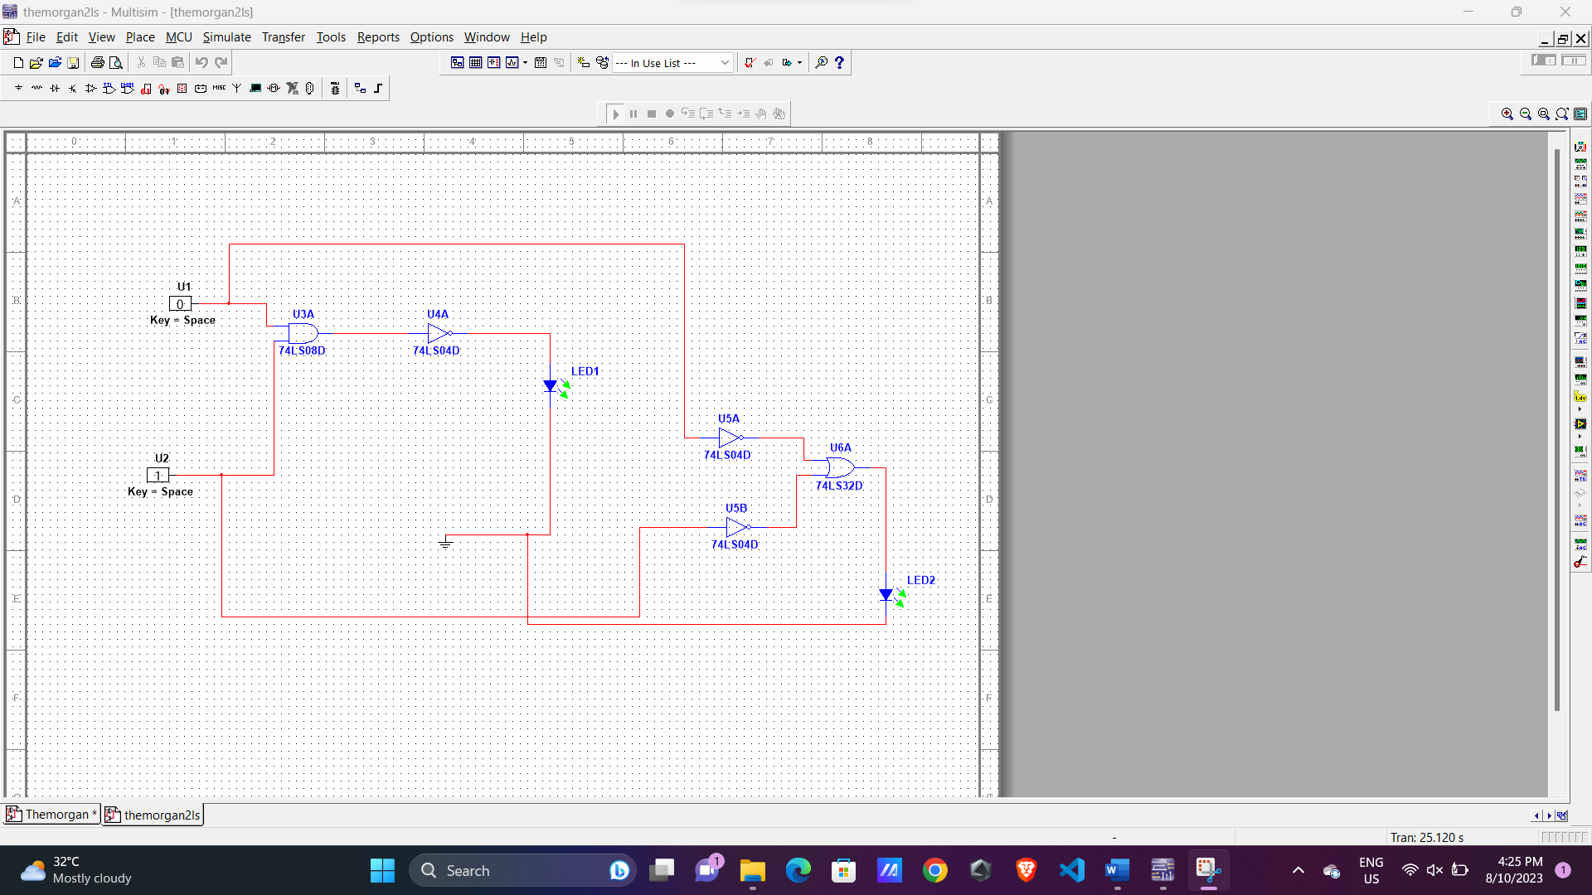

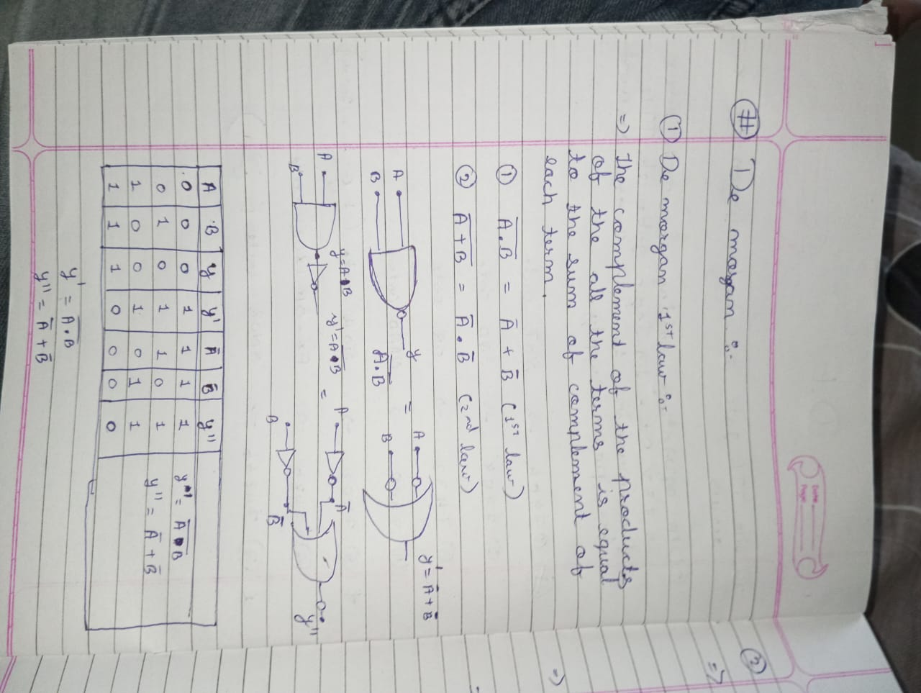

* + - **[B]** Statement and proof of De’Morgan’s second Law :

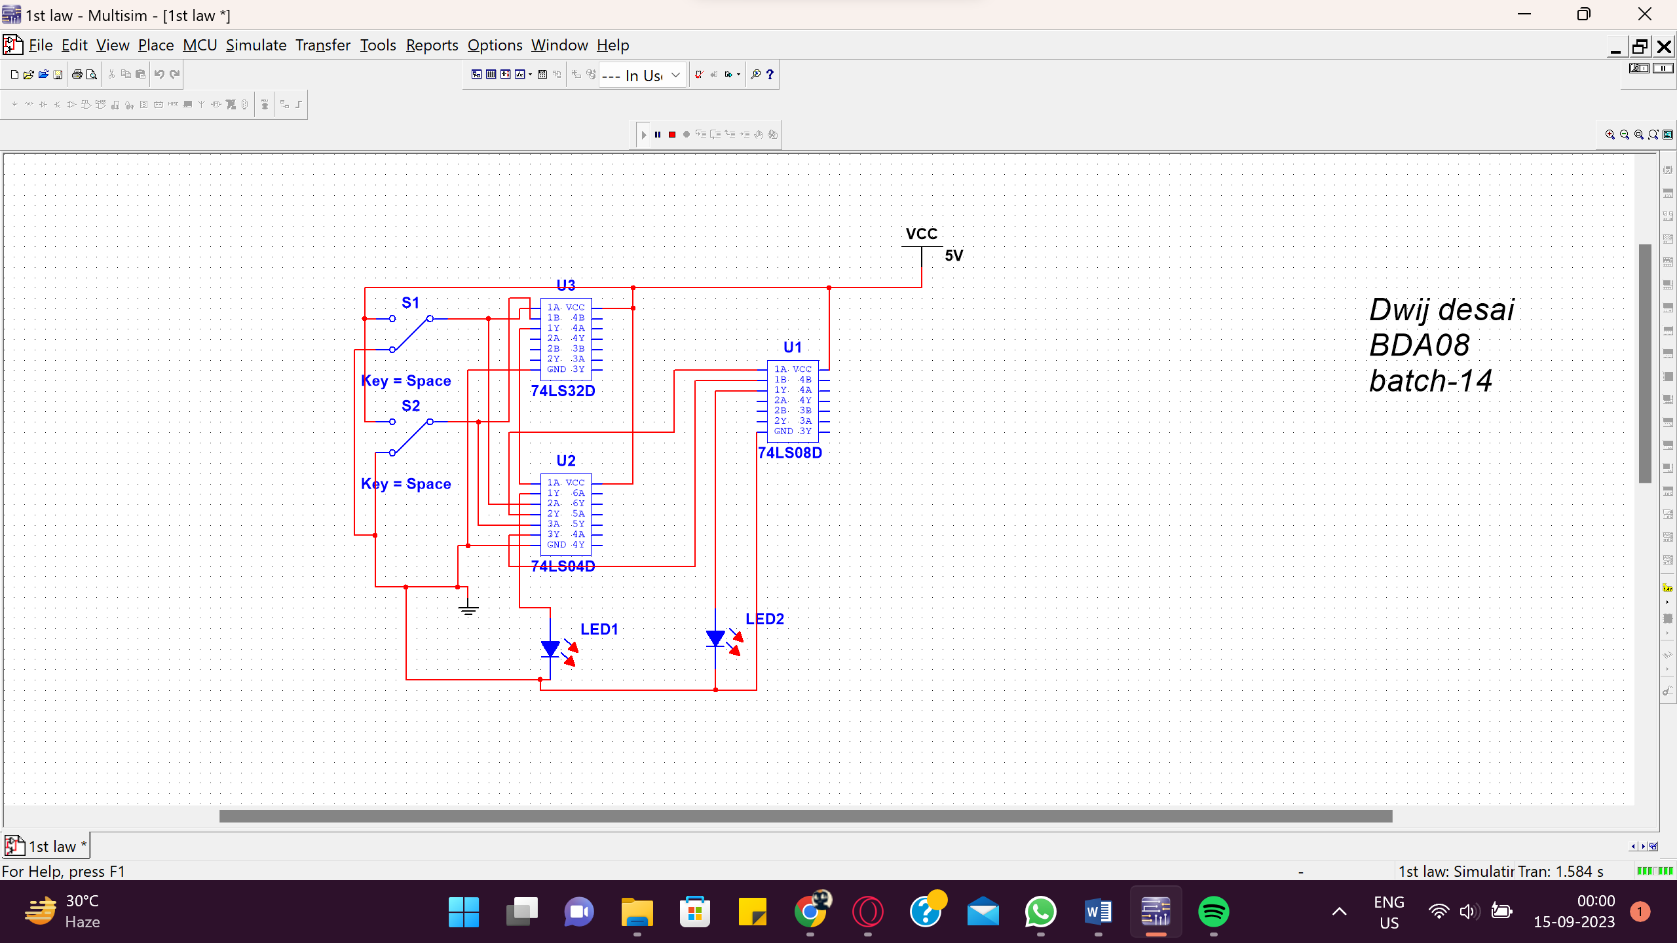

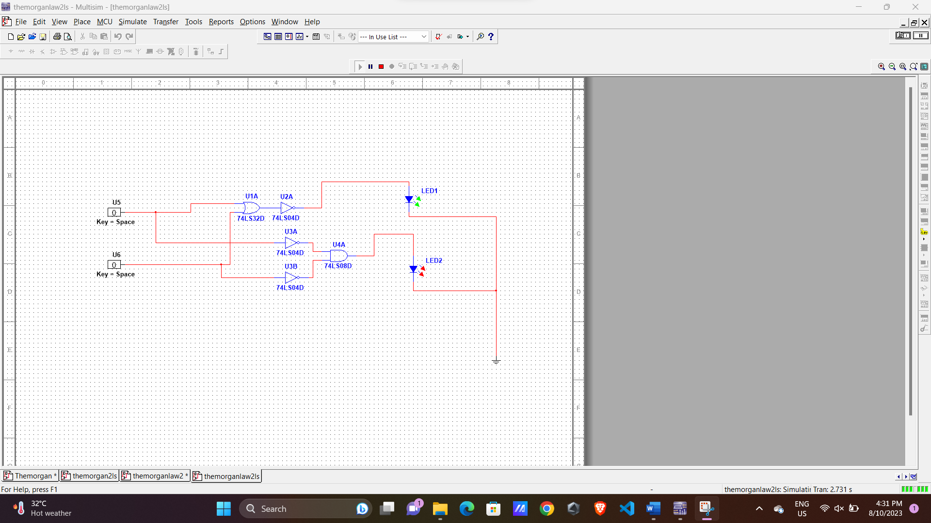

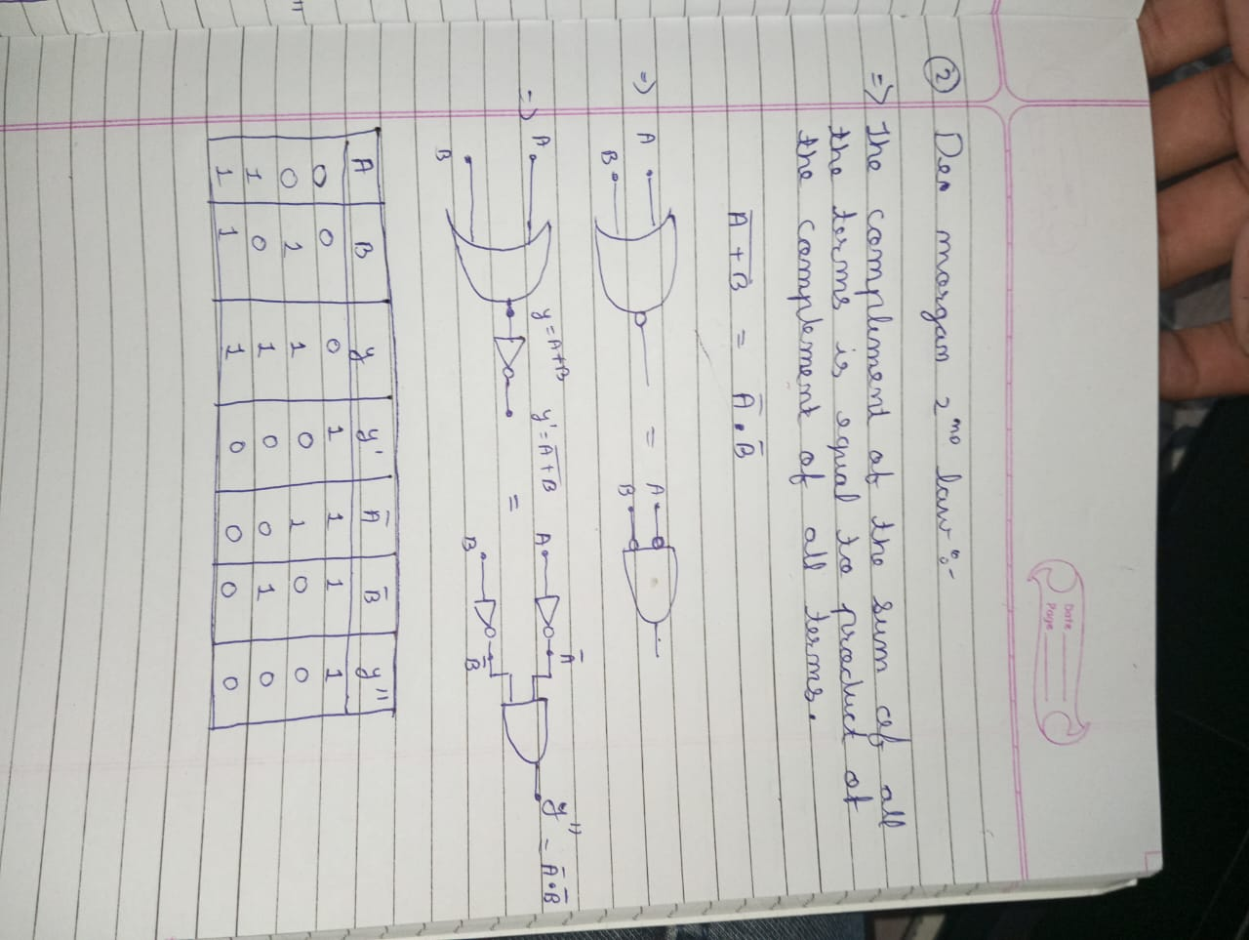

* + - **PROCEDURE:**

1. Connect the circuit on the bread board using ICs.
2. Switch ON the power supply.
3. Test the truth table of different gates by changing the input levels (i.e. ‘1’ means HIGH & ‘0’ means LOW) and check the level of output voltage.(if LED glows it is at level ‘1’ and if LED doesn’t glow output is at level ‘0’).
4. Verify that the De’Morgan’s laws are proved.